Automated Network Request Management in ServiceNow

Project Report

Date | 09 September 2026
Student Name | Vijjapu Madhuri
Project Name | Automated Network Request Management in ServiceNow

INTRODUCTION
  - Project Overview
  - Purpose

IDEATION PHASE
  - Problem Statement
  - Empathy Map Canvas
  - Brainstorming

REQUIREMENT ANALYSIS
  - Customer Journey map
  - Solution Requirement
  - Data Flow Diagram
  - Technology Stack

PROJECT DESIGN
  - Problem Solution Fit
  - Proposed Solution
  - Solution Architecture

PROJECT PLANNING & SCHEDULING
  - Project Planning

FUNCTIONAL AND PERFORMANCE TESTING
  - Performance Testing

RESULTS
  - Output Screenshots
- ADVANTAGES & DISADVANTAGES
- CONCLUSION
- FUTURE SCOPE
- APPENDIX
Source Code(if any) Dataset Link
GitHub & Project Demo Link

1. INTRODUCTION

1.1 Project Overview
The Automated Network Request Management in ServiceNow project is designed to provide a centralized platform for submitting, processing, approving, tracking, and managing network-related service requests. The system uses the ServiceNow platform to automate the complete request lifecycle and reduce manual effort.
The application provides a Network Request Catalog Item through the ServiceNow Service Portal. Users can enter the required network request information, submit the request, and track its progress. The submitted request is processed through an automated workflow using Flow Designer, where approval, record creation, notifications, and status updates are handled systematically.
The project improves the efficiency of network service management by maintaining request information in a centralized Network Database and providing controlled access through ServiceNow security and ACL configurations.

1.2 Purpose
The main purpose of this project is to automate the network request management process using ServiceNow.
The project aims to:
- Simplify the process of submitting network-related requests.
- Reduce manual processing and administrative effort.
- Automate request validation and workflow processing.
- Route requests for approval automatically.
- Store request information in a centralized Network Database.
- Send automated email notifications for important request updates.
- Allow users to track request and approval status.
- Provide controlled access to network request records.
- Improve transparency and efficiency throughout the request lifecycle.

2. IDEATION PHASE

2.1 Problem Statement
In a manual network request management process, users may need to communicate their requirements through emails, messages, or other channels. This can result in delays, incomplete information, difficulty in tracking requests, and additional manual work for administrators.
There may also be no centralized location to maintain all network request information, making it difficult to monitor request progress and approval status.
The proposed project addresses these issues by providing a centralized ServiceNow-based system where users can submit network requests through a structured form. The system automates processing, approval, notification, and status tracking.

Problem Statement:
"To develop an automated and centralized network request management system using ServiceNow that simplifies request submission, automates approval and processing, provides real-time status visibility, and reduces manual intervention."
2.2 Empathy Map Canvas

Empathy Map Canvas
Dimension | Employee / Network Requester Perspective
Says | Needs an easy way to raise a network request; expects the required details to be clear and the request to move without unnecessary delays.
Thinks | Checks the ServiceNow portal, opens the network request option, enters connection and contact details, and submits the form.
Does | Expects the request to be handled smoothly and feels more confident when the current status is easy to follow.
Feels | Repeated data entry, missing details, unclear next steps, limited progress updates, and delays in fulfilment.
Pain Points | Guided request entry, accurate information capture, timely processing, visible progress, and dependable service delivery.
Needs / Goals | Simple and intuitive request submission, fast turnaround, status visibility, faster request fulfilment, and reliable service delivery.

End User (Requester) — Empathy Map
“I want to raise a network request without confusion or repeated follow-up.”  “I want a simple and intuitive way to submit a network service request.” |  | Expects the form to ask for the right details and make the next step clear.  Wants the request form to clearly capture the required details and expects a straightforward process.
 | REQUESTER
Opens the Service Portal, selects the network request option, enters the required information, and submits it.  Accesses the Service Portal, searches for Network Requests, fills in the required details, and submits the request. |  | Feels more comfortable when the request progress and approval status are visible.  Wants a faster, more reliable experience; may feel uncertain when status visibility is limited.

2.3 Brainstorming

Idea Prioritization
The prioritization below considers the main building blocks of the Automated Network Request Management project — request entry, form data, workflow automation, approvals, records, communication, security, and validation. Each item is rated High or Medium according to its contribution to a smoother request experience, implementation practicality, and dependency on other features.
Idea Group / Feature | Purpose in Project | Priority | Reason for Priority
Network Request Service Catalog | Service Catalog item (Category: Network) provides a standard starting point for employees to raise new or existing connection requests. | High | Creates a consistent entry point and avoids requests being handled through disconnected manual channels.
Network Request Form and Variables | Collects details such as Requested For, Mobile Number, Type of Connection, Existing ID, Total Amount, Mode of Payment, Address, and the Opened on Behalf Of variable set. | High | Improves the quality of information received by the fulfilment team and reduces back-and-forth with the requester.
Flow Designer Automation | Uses Get Catalog Variables, Create Record, Send Email, Ask for Approval, If/Else logic, and Update Record to move the request through defined stages after submission. | High | Connects the major steps into one automated lifecycle and reduces dependency on manual coordination.
Approval Routing | Uses the Ask for Approval action and Approval Request related list so requests can be reviewed before fulfilment. | High | Introduces a controlled checkpoint and makes the approval decision traceable.
Network Database Record Creation | Creates a Network Database record containing the information needed by administrators and the network fulfilment team to work on the request. | High | Provides one operational record for assignment, processing, approval information, and follow-up.
Dynamic Form Behaviour | Uses a Catalog UI Policy so the Existing ID field is shown when the requester selects an existing connection. | Medium | Keeps the form relevant to the selected connection type and avoids asking for unnecessary information.
Email Notifications | Uses the Send Email action to inform relevant users when important request events occur. | Medium | Keeps stakeholders informed without requiring them to repeatedly check the system.
Request Tracking / Status Visibility | Uses the Approval Status value on the Network Database record to indicate the current position of the request. | Medium | Helps users understand whether a request is awaiting action, approved, or requires attention.
Access Control | Applies ACLs and Access Control Rules to limit who can view or update sensitive Network Database information. | Medium | Supports role-based access and protects request information while depending on the underlying table design.
Validation and Testing | Checks mandatory data, form behaviour, record creation, notification steps, and approval outcomes through testing and User Acceptance Testing. | Medium | Helps identify workflow or data issues before the solution is used in the live environment.

Prioritization Overview
The card view below summarizes the main project components together with their assigned priority levels.
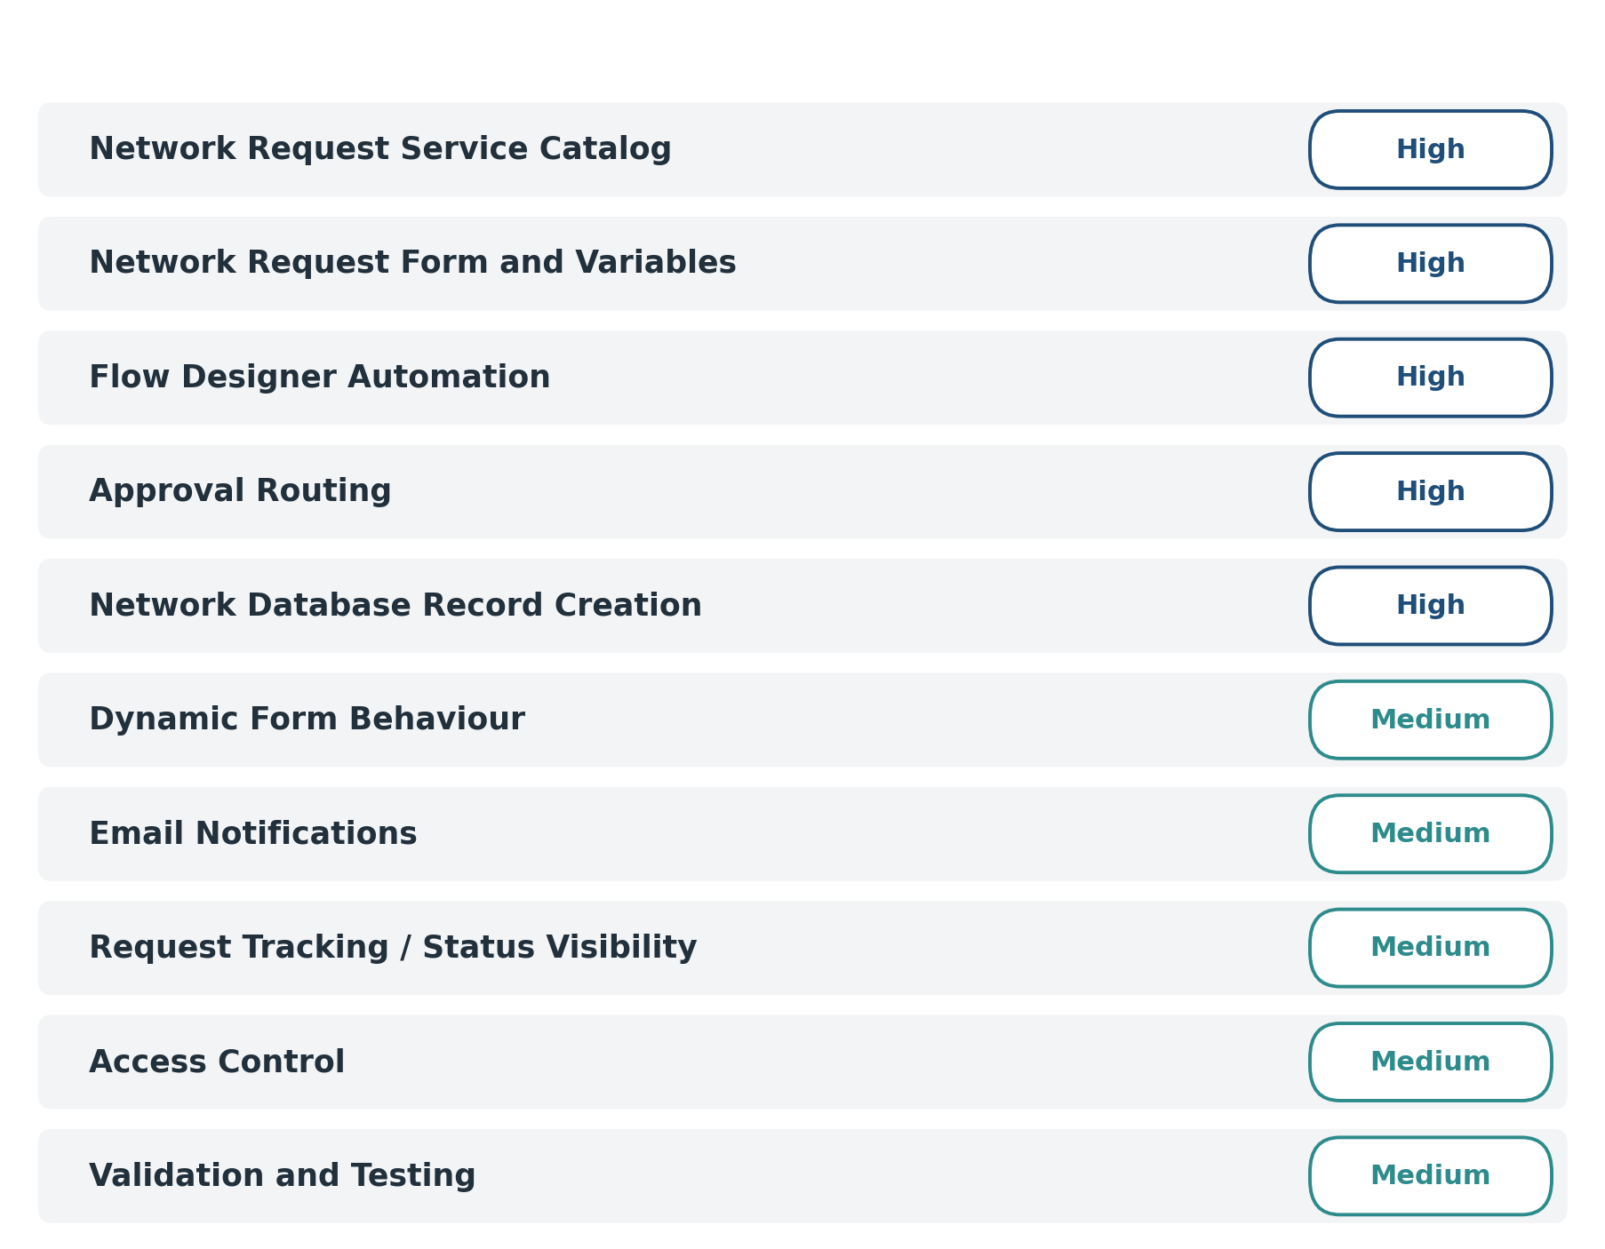

3. REQUIREMENT ANALYSIS

3.1 Customer Journey Map
The customer journey represents the steps followed by a user from submitting a network request until the request is processed.
Stage | User Activity | System Response | User Experience
1. Request Identification | User identifies the need for a network connection/service. | User accesses the ServiceNow Service Portal. | Easy access to the service.
2. Request Submission | User opens the Network Request Catalog Item. | System displays the request form. | Simple and structured form.
3. Information Entry | User enters requester, connection, payment, amount, and address details. | System validates the entered information. | Guided data entry.
4. Conditional Selection | User selects the type of connection. | Existing ID is displayed when Existing connection is selected. | Relevant fields are shown dynamically.
5. Request Creation | User submits the request. | Flow Designer processes the request and creates the required record. | Request is processed automatically.
6. Approval | Request moves through the approval process. | Approval request is generated. | Clear approval process.
7. Notification | Request progresses through workflow stages. | Automated email notifications are generated. | User receives updates.
8. Status Tracking | User checks the request progress. | Request/Approval Status is updated. | Better visibility.
9. Completion | Request completes the required process. | Final status is reflected in the system. | Complete and traceable process.

3.2 Solution Requirement

Functional Requirements
Requirements are grouped in the order they execute during a request's lifecycle, from intake through verification.
ID | Capability | What It Covers | Depends On
FR-01 | Network Request Submission | The system shall provide a Network Request Catalog Item through the ServiceNow Service Portal so that users can submit network-related requests. | —
FR-02 | Request Information Capture | The catalog item shall capture the required information provided by the requester, including requester details, mobile number, connection type, address, existing connection information where applicable, and other configured request details. | FR-01
FR-03 | Mandatory Field Validation | The system shall ensure that all required fields are completed before the requester can submit the network request. | FR-02
FR-04 | Conditional Field Handling | The Existing ID field shall be displayed only when the requester selects Existing as the connection type. | FR-02
FR-05 | Automated Workflow Trigger | Once the Network Request is submitted, the configured ServiceNow Workflow/Flow Designer automation shall start automatically without requiring manual intervention. | FR-01 – FR-04
FR-06 | Retrieve Request Details | The workflow shall retrieve the information submitted through the Network Request Catalog Item and use it for further processing. | FR-05
FR-07 | Network Database Record Creation | The workflow shall automatically create a corresponding record in the Network Database using the submitted request information. | FR-06
FR-08 | Request Data Mapping | The information entered by the requester shall be mapped correctly to the corresponding fields in the Network Database record. | FR-07
FR-09 | Approval Request | After the Network Database record is created, the workflow shall generate an approval request for the configured approver. | FR-07
FR-10 | Approval Decision | The approver shall be able to review the request and select an appropriate decision such as Approve or Reject. | FR-09
FR-11 | Decision-Based Processing | The workflow shall use an If/Else decision to determine the next action based on the approval outcome. | FR-10
FR-12 | Record Status Update | The Network Database record shall be updated automatically according to the approval decision. | FR-11
FR-13 | Notification | The workflow shall send an email notification to the configured recipients after the request reaches the notification step. | FR-12
FR-14 | Request Status Tracking | Users and authorised stakeholders shall be able to view the current status and approval information from the corresponding Network Database record. | FR-12
FR-15 | Access Control | Access to the Network Database and related records shall be restricted to authorised ServiceNow users and roles. | FR-07
FR-16 | Workflow Verification | The complete request lifecycle shall be tested to verify catalog submission, workflow execution, record creation, approval, decision handling, status update, and notification. | FR-01 – FR-15

Non-Functional Requirements
Quality Attribute | How the Solution Addresses It
Usability | The Network Request is provided through the ServiceNow Service Portal with a structured form, mandatory fields, and conditional field behaviour to make submission simple for the requester.
Automation | The request lifecycle is automated using ServiceNow Workflow/Flow Designer, reducing the need for manual processing after submission.
Security | Access to network request records is restricted through ServiceNow roles and access controls so that only authorised users can access or modify the records.
Reliability | The workflow is designed to consistently execute the configured sequence of record creation, approval, decision handling, status update, and notification.
Data Accuracy | Request information submitted through the catalog item is mapped to the Network Database record to maintain consistent and structured request data.
Performance | Automation reduces manual processing time and provides a faster request-handling process. No specific numerical response-time target was defined for this project.
Maintainability | The solution uses ServiceNow's standard catalog, database, workflow/flow, approval, notification, and access-control features, making the configuration easier to maintain.
Scalability | Additional network request fields, approval conditions, notifications, or workflow steps can be incorporated into the existing ServiceNow solution as requirements grow.
Availability | The solution operates within the ServiceNow platform and uses the platform's native services for catalog requests, workflow automation, records, approvals, and notifications.
Traceability | The request information, database record, approval outcome, and updated status are maintained within ServiceNow, allowing the request lifecycle to be tracked.

3.3 Data Flow Diagram

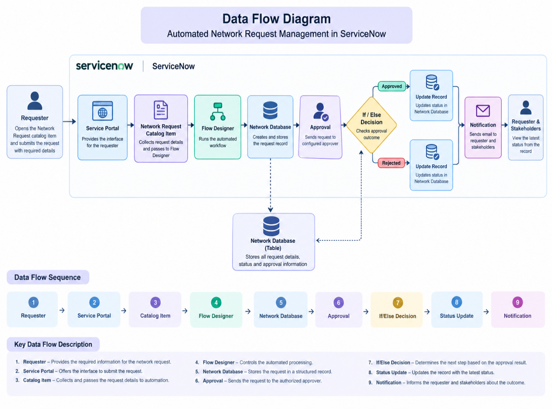

3.4 Technology Stack

Layer-by-Layer Breakdown
Layer | Purpose | Technology Used
User / Client Layer | Provides the interface through which the requester accesses and submits the network request. | ServiceNow Service Portal
Service Catalog Layer | Provides the Network Request catalog item and collects the information required from the requester. | ServiceNow Service Catalog
Form Validation Layer | Handles mandatory fields and controls field behaviour based on the values entered by the requester. | Catalog Configuration, UI Policies / Client-side configuration
Automation Layer | Processes the submitted request automatically, creates the database record, sends the approval request, handles the decision, and updates the record. | ServiceNow Workflow / Flow Designer
Data Layer | Stores the submitted network request information and maintains the request status and approval information. | Custom Network Database Table
Approval Layer | Sends the created network request for review and captures the approver's decision. | ServiceNow Approval
Decision Layer | Determines the next step based on whether the request is approved or rejected. | If/Else workflow logic
Notification Layer | Sends email notifications to the configured users or stakeholders during the request process. | ServiceNow Email / Workflow Notification
Security Layer | Controls access to the network request records based on authorised users and roles. | ServiceNow Roles and ACLs
Runtime Environment | Provides the environment in which the application is configured, tested, and demonstrated. | ServiceNow Personal Developer Instance (PDI)
External Integration Layer | No external application or third-party system is required for the implemented solution. | Not applicable
AI / Intelligence Layer | No AI, machine-learning, or predictive functionality is included in the current project. | Not applicable

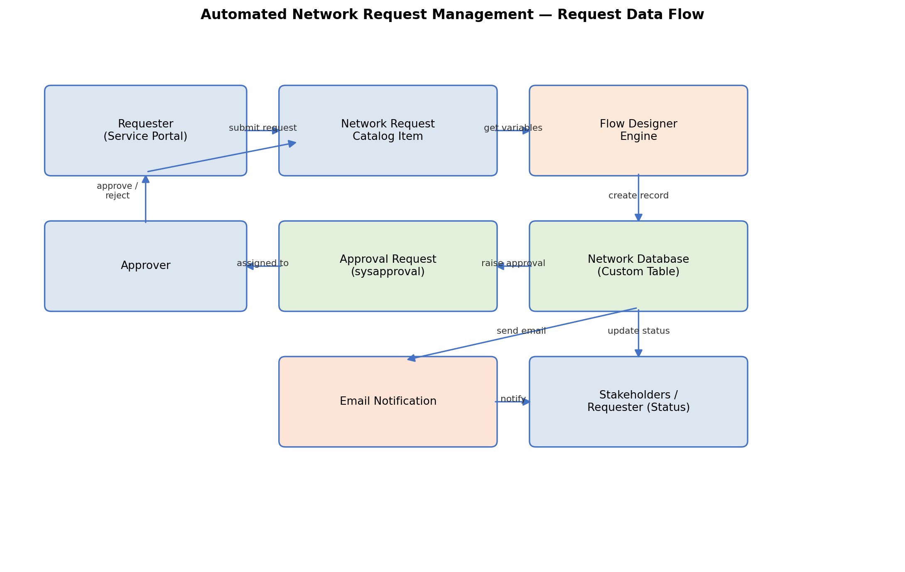
Figure 1: Request flow across the ServiceNow components listed above.

Component Interaction

Service Portal
The Service Portal acts as the entry point for the requester. The requester accesses the Network Request catalog item and provides the required information.

Network Request Catalog Item
The catalog item collects the network request information entered by the requester. Mandatory fields and configured form behaviour help ensure that the required information is provided before submission.

Workflow Automation
After submission, the configured ServiceNow workflow automation processes the request. It retrieves the submitted information, creates the corresponding Network Database record, initiates the approval process, evaluates the approval result, and performs the required record updates.

Network Database
The custom Network Database table stores the request information in a structured ServiceNow record. It also maintains information related to the request status and approval outcome.

Approval
The approval step sends the network request to the configured approver. The approver reviews the request and provides an approval or rejection decision.

If/Else Decision
The workflow evaluates the approval result using conditional logic. The appropriate branch is executed depending on whether the request is approved or rejected.

Record Update
After the approval decision, the Network Database record is automatically updated so that the latest status is available for tracking.

Notification
The configured notification step sends an email to the relevant recipients, keeping them informed about the request process or outcome.

4. PROJECT DESIGN

4.1 Problem Solution Fit

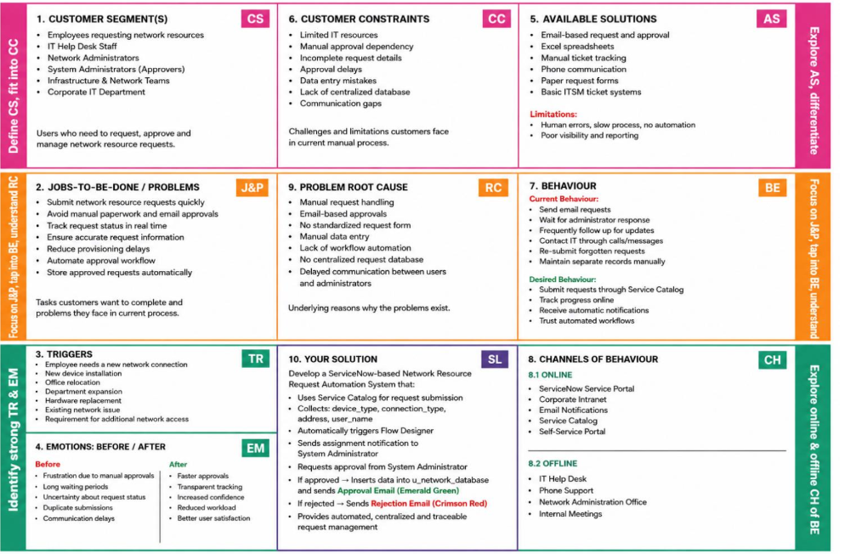
4.2 Proposed Solution

S.No. | Parameter | Description
1 | Problem Statement (Problem to be solved) | Organizations often handle network-related requests manually through emails, calls, or messages. This can lead to delays, missing information, difficulty in tracking requests, and lack of proper approval and status visibility. A structured system is needed to automate and manage network requests efficiently.
2 | Idea / Solution description | The proposed solution is an Automated Network Request Management System using ServiceNow. A user submits a network request through the ServiceNow Service Catalog by providing the required details. The request is automatically validated and routed through a workflow for approval. Once approved, the request is processed and its status is updated automatically, providing better tracking and visibility throughout the process.
3 | Novelty / Uniqueness | The solution combines ServiceNow Service Catalog, Workflow/Flow Designer, approvals, validations, and automated status updates into a single system. It reduces manual coordination and provides a standardized process for handling network requests. Users can easily submit and track requests without depending on emails or manual follow-ups.
4 | Social Impact / Customer Satisfaction | The system improves user satisfaction by making network request submission faster, simpler, and more transparent. Users receive a clear status of their requests and do not need to repeatedly contact support teams for updates. It also helps IT teams reduce repetitive manual work and respond to requests more efficiently.
5 | Business Model (Revenue Model) | The solution can be implemented as part of an organization's ServiceNow IT service management platform. Organizations can use it to reduce operational costs, improve IT service efficiency, and minimize manual effort. ServiceNow implementation, customization, maintenance, and support can generate revenue for IT service providers and implementation partners.
6 | Scalability of the Solution | The solution can be easily extended to support different types of network requests, such as VPN access, firewall access, IP requests, network configuration, and connectivity issues. Additional workflows, approval levels, notifications, dashboards, and automation can be added as the organization grows. The same approach can also be adapted for other IT service request processes.

4.3 Solution Architecture

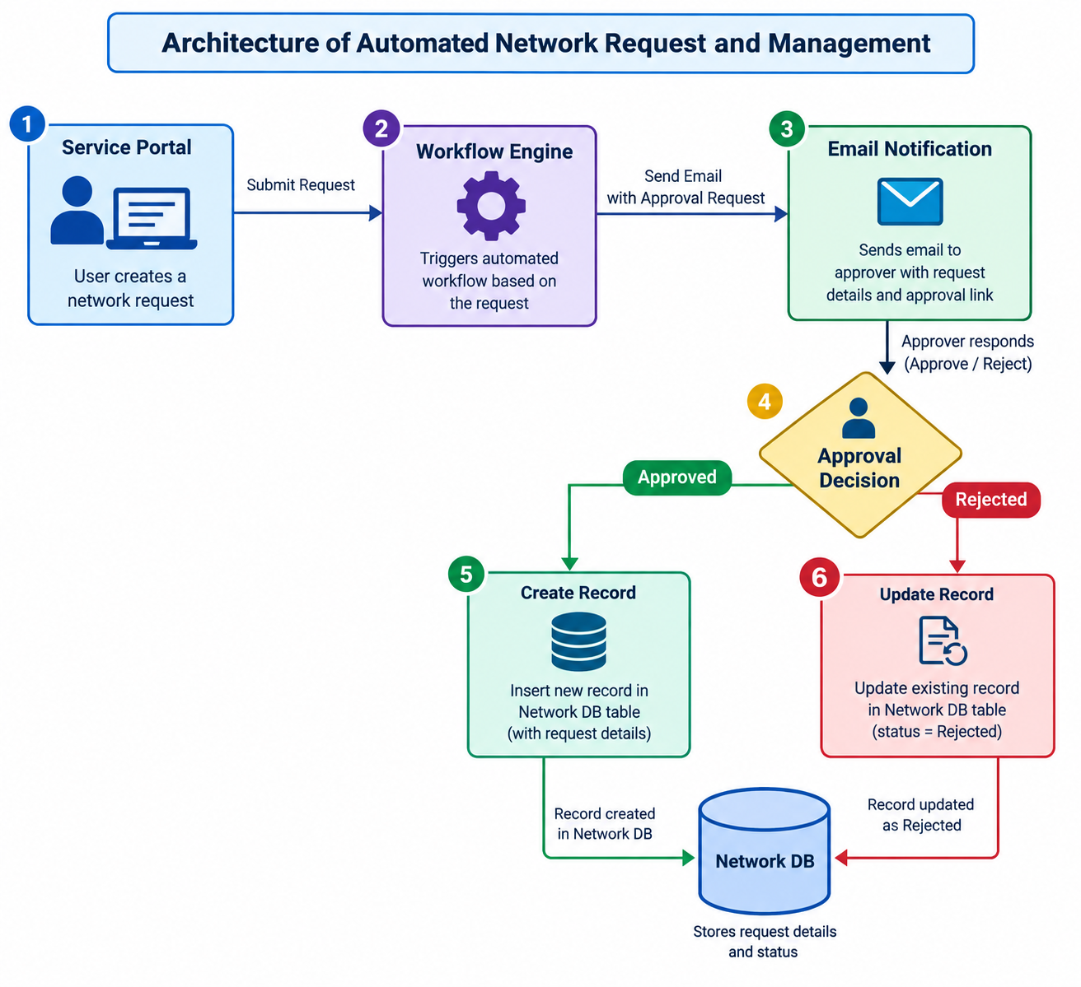

5. PROJECT PLANNING & SCHEDULING

5.1 Project Planning
The project was planned in multiple phases to ensure that the ServiceNow application was developed and tested systematically.
Phase | Activities
Phase 1 – Requirement Analysis | Identify the network request problem, users, requirements, and expected workflow.
Phase 2 – Application Design | Design the request form, database structure, workflow, approval process, and security requirements.
Phase 3 – ServiceNow Configuration | Create the application components, catalog item, variables, variable set, and Network Database.
Phase 4 – Workflow Automation | Configure Flow Designer, approval processing, notifications, and status updates.
Phase 5 – Security Configuration | Configure roles and ACLs for controlled access.
Phase 6 – Testing | Perform functional testing of request submission, validation, workflow, approval, notifications, status tracking, and access control.
Phase 7 – Final Validation | Perform end-to-end validation and verify that the complete workflow operates correctly.

Sprint Planning
The work can be organized into the following sprints:
Sprint | Main Activities
Sprint 1 | Requirement analysis, application planning, and Network Request form design
Sprint 2 | Catalog item, variables, variable set, and Network Database configuration
Sprint 3 | Flow Designer, approvals, notifications, and status tracking
Sprint 4 | ACL configuration, testing, validation, and documentation

6. Functional and Performance Testing

6.1 Performance Testing

Test Scenarios & Results
Test ID | Scenario | Expected Result | Status
TC-01 | Verify access to Network Request Service Portal | The ServiceNow portal opens successfully and the user can locate the Network Request option. | Pass
TC-02 | Verify Network Request form configuration | The Network Request form opens correctly and displays all configured fields and variable sets. | Pass
TC-03 | Validate mandatory request information | The system accepts the request only after the required requester, connection, payment, amount, and address information has been entered correctly. | Pass
TC-04 | Verify conditional field behavior | When Type of Connection is changed to Existing, the Existing ID field becomes visible; it remains hidden for other connection types. | Pass
TC-05 | Validate automated request creation | After submitting valid information, the configured Flow Designer flow executes and creates the corresponding record in the Network Database. | Pass
TC-06 | Verify approval workflow | The submitted request is routed through the configured approval process and an approval record is generated for the appropriate approver. | Pass
TC-07 | Verify request notification mechanism | Configured email notifications are generated and sent to the intended users when the request reaches the relevant workflow stage. | Pass
TC-08 | Verify request lifecycle status | Changes in the request workflow are reflected in the Network Database through the configured Approval Status field. | Pass
TC-09 | Verify table-level security | Users can perform only the read/write operations permitted by the configured ACL rules on the Network Database. | Pass
TC-10 | Validate complete automated workflow | A valid request successfully progresses from submission through validation, record creation, approval, notification, status tracking, and completion without workflow errors. | Pass

Functional & Performance Testing Results

Test ID | Scenario | Status
TC-01 | Verify ServiceNow portal accessibility | PASS
TC-02 | Access and verify the Network Request catalog item | PASS
TC-03 | Verify entry of required network request details | PASS
TC-04 | Validate conditional display of Existing ID field | PASS
TC-05 | Verify successful submission and automated request record creation | PASS
TC-06 | Validate automatic approval request creation | PASS
TC-07 | Verify automated notification for request updates | PASS
TC-08 | Verify tracking of request approval and processing status | PASS
TC-09 | Validate user access permissions for Network Database records | PASS
9/9 functional scenarios passed

7. Results

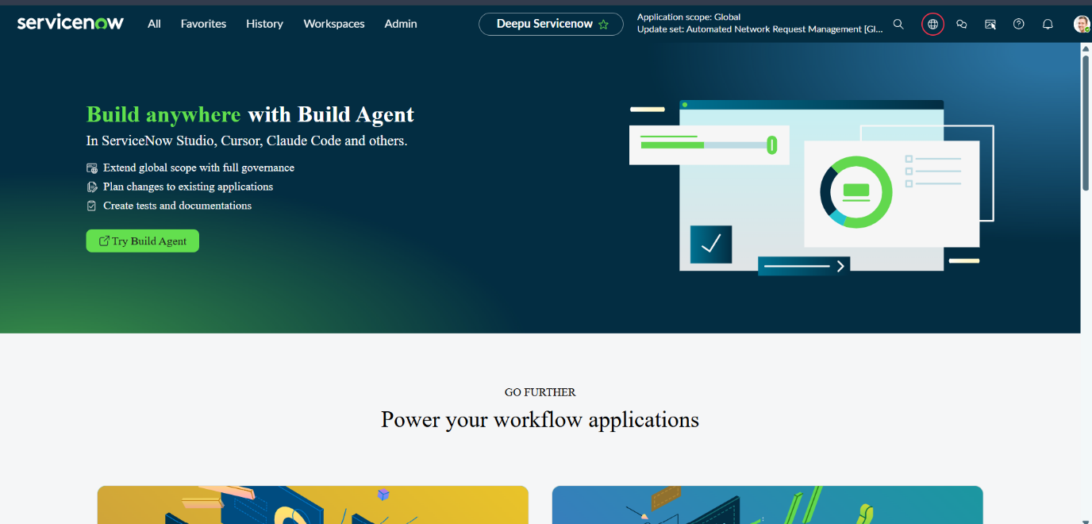
Fig.1 Servicenow Home page

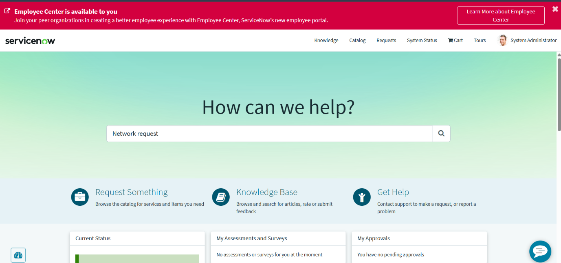
Fig.2 Service Portal

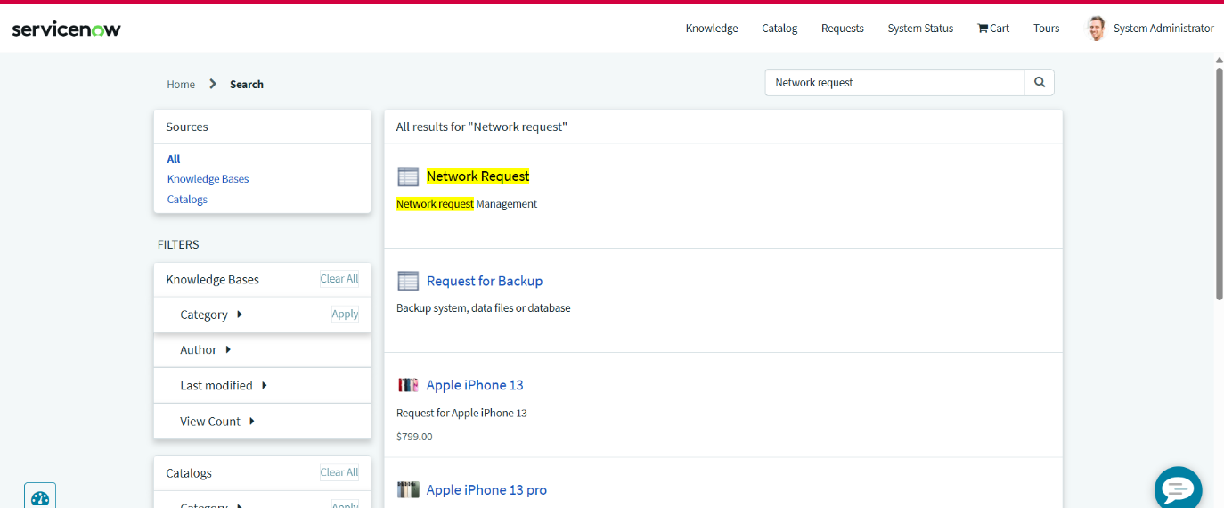
Fig.3 Search and open Network Request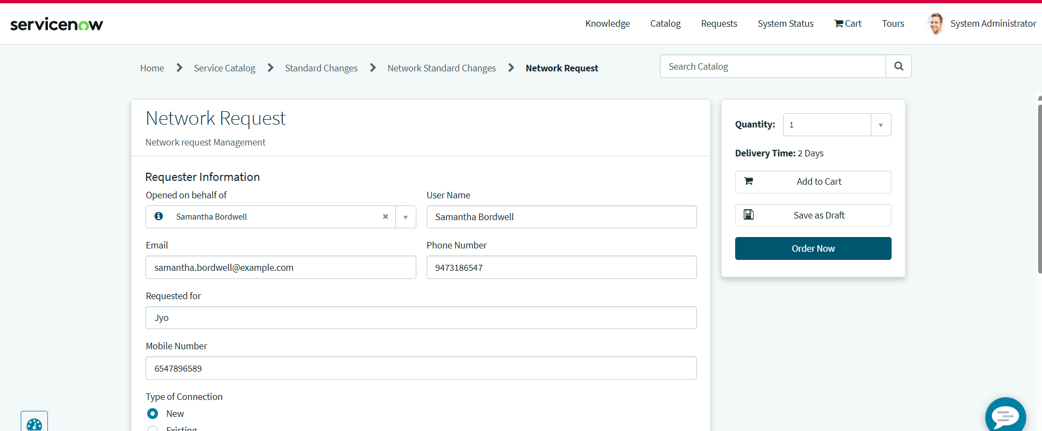
Fig.4 Enter the details and click on order now

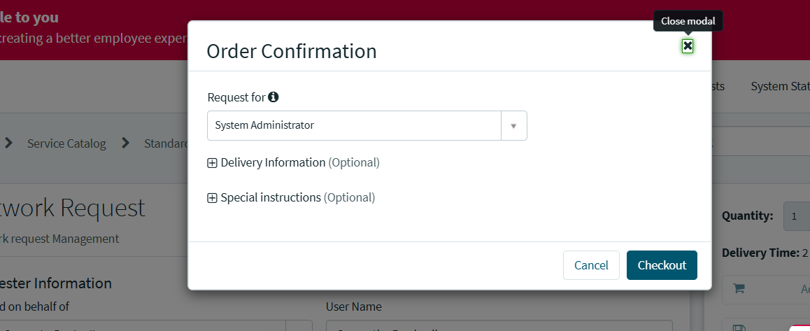
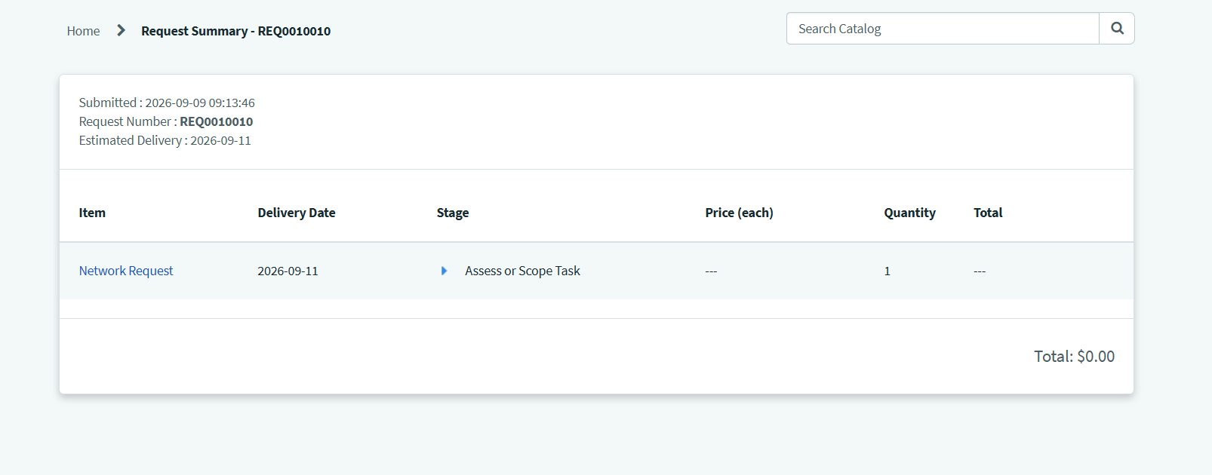
Fig.5 Checkout and Request Summary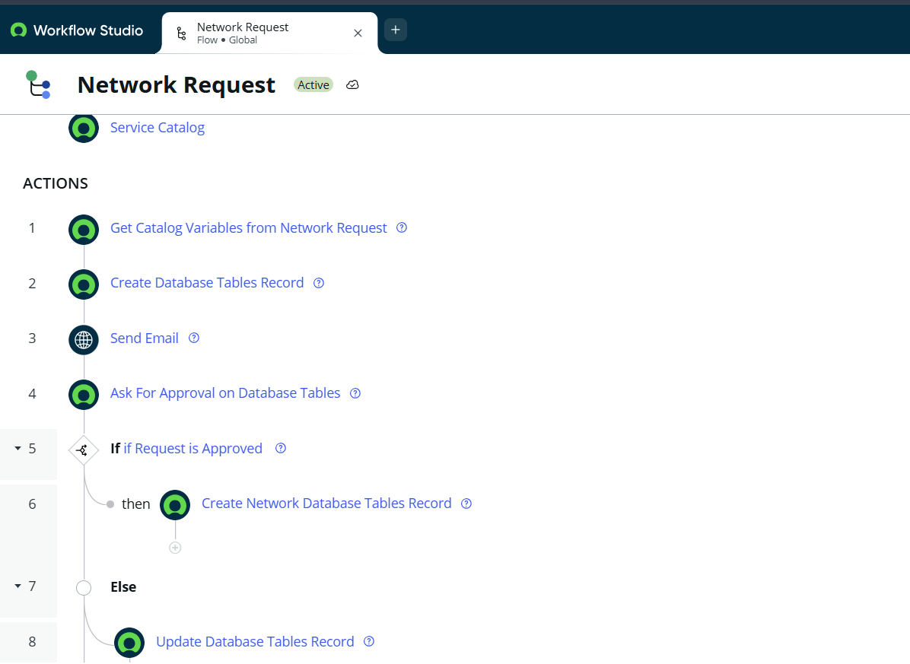
Fig.6 Work Flow for Automation

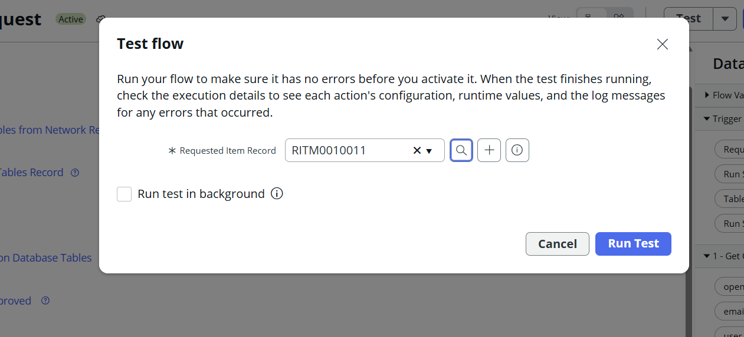
Fig.7 Test the flow by selecting the record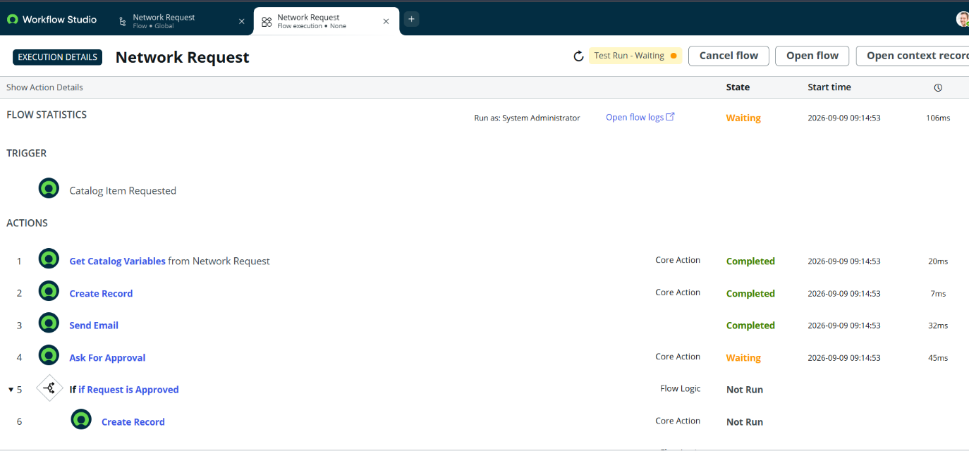
Fig.8 Its waiting for Approval and email sent

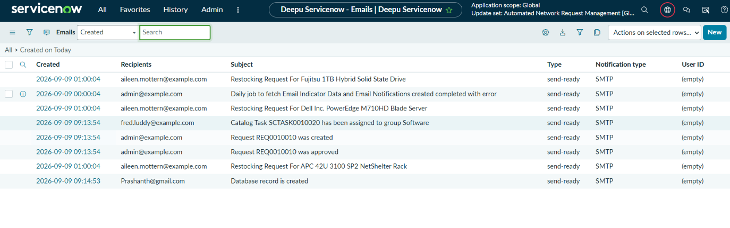
Fig.9 Email

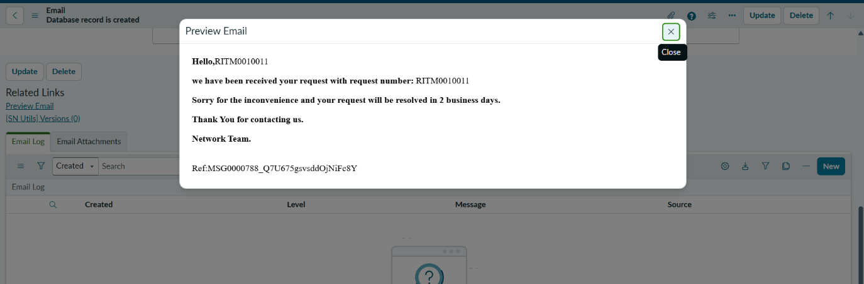
Fig.10 Email Preview

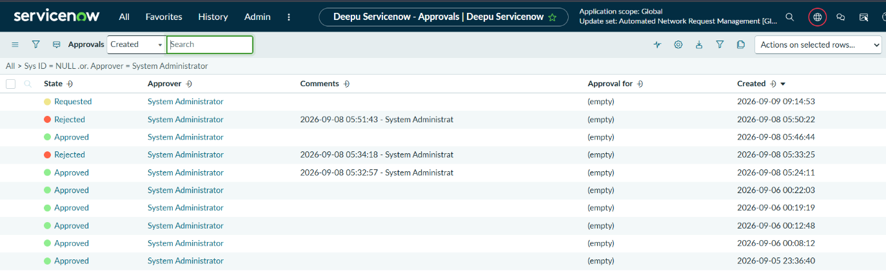
Fig.11 Approval Request

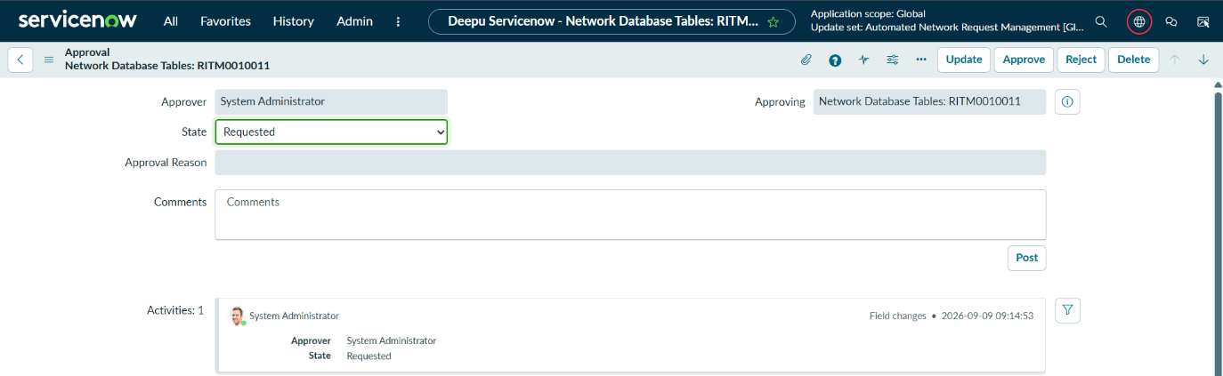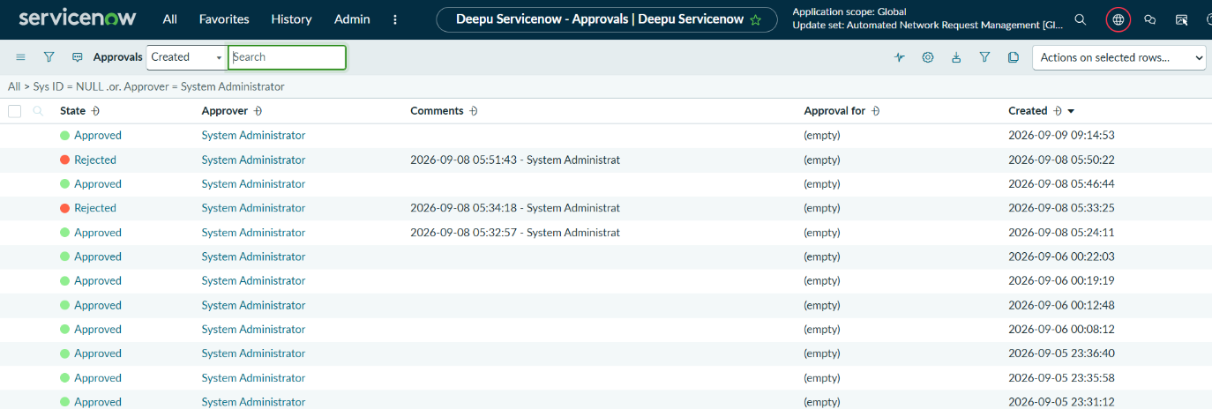
Fig.12 Request Approval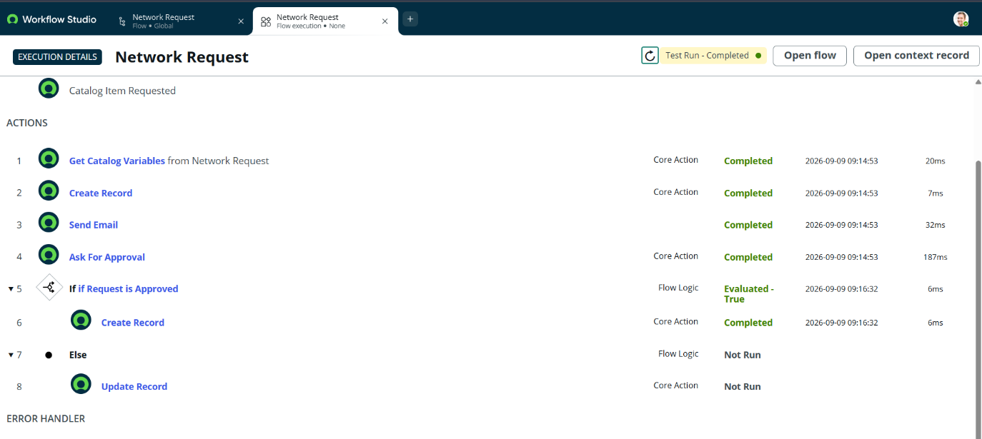
Fig.13 Retest and check the flow
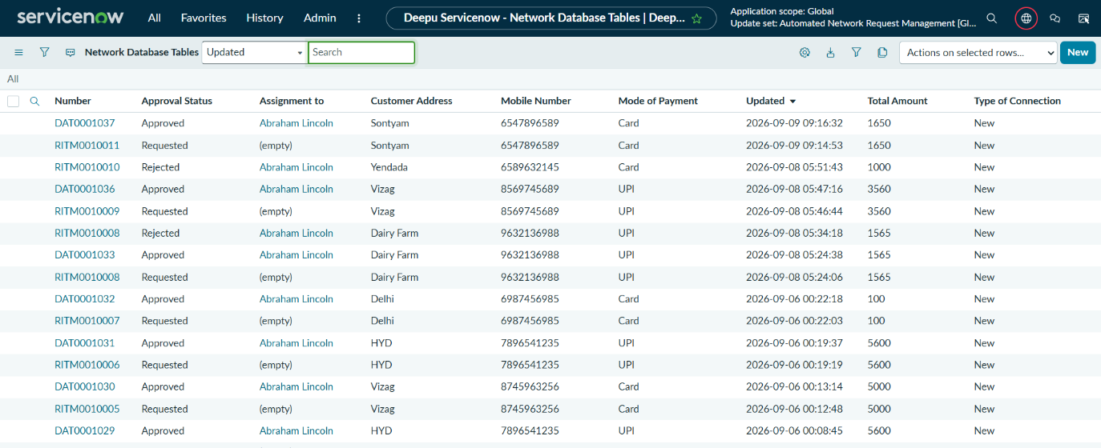
Fig.14 Creates a record as Approved

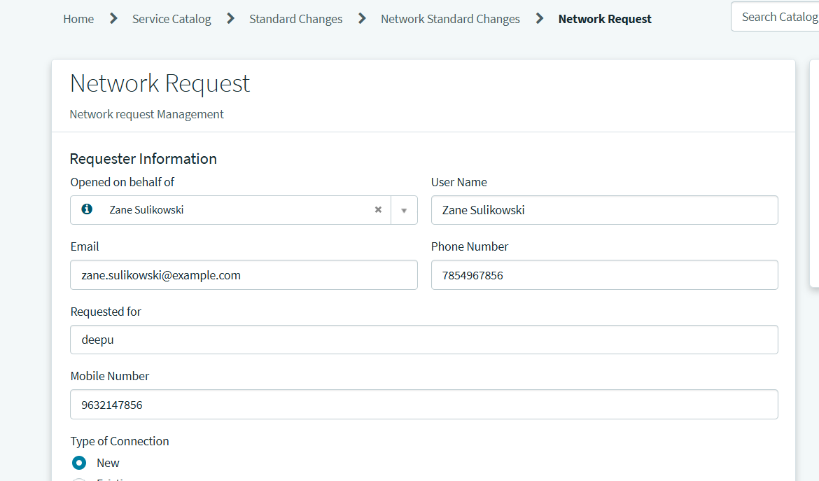
Fig.15 Create record to check what happens if approval rejected

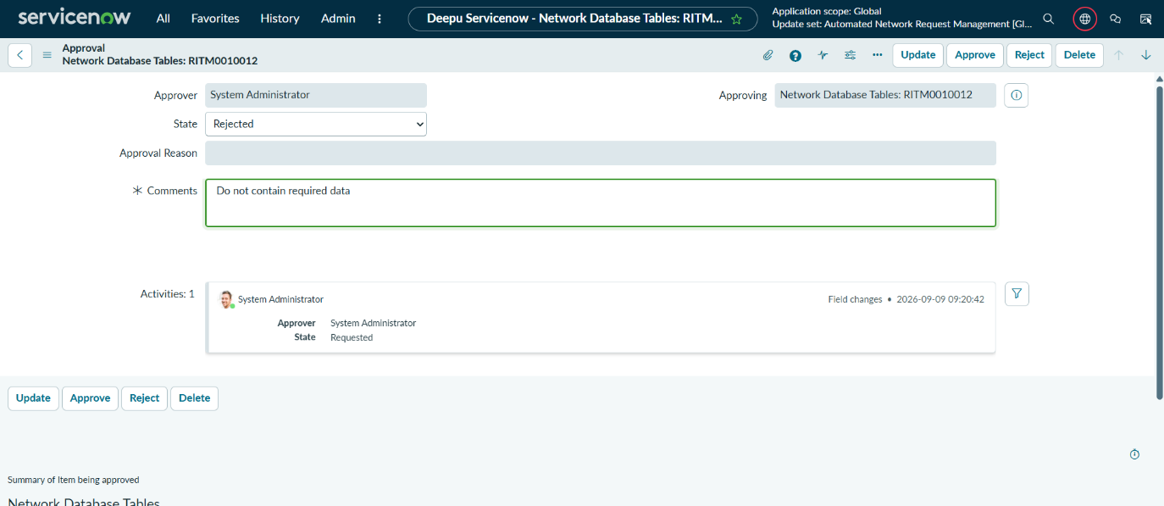
Fig.16 Reject and give comments why it is rejected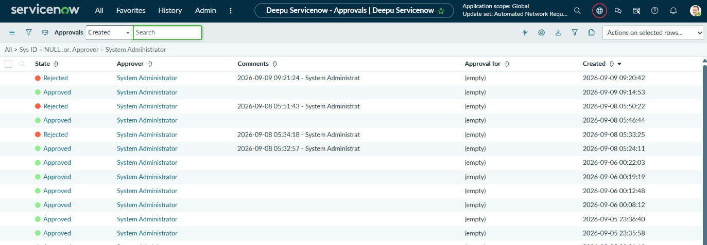
Fig.17 Approval Rejected

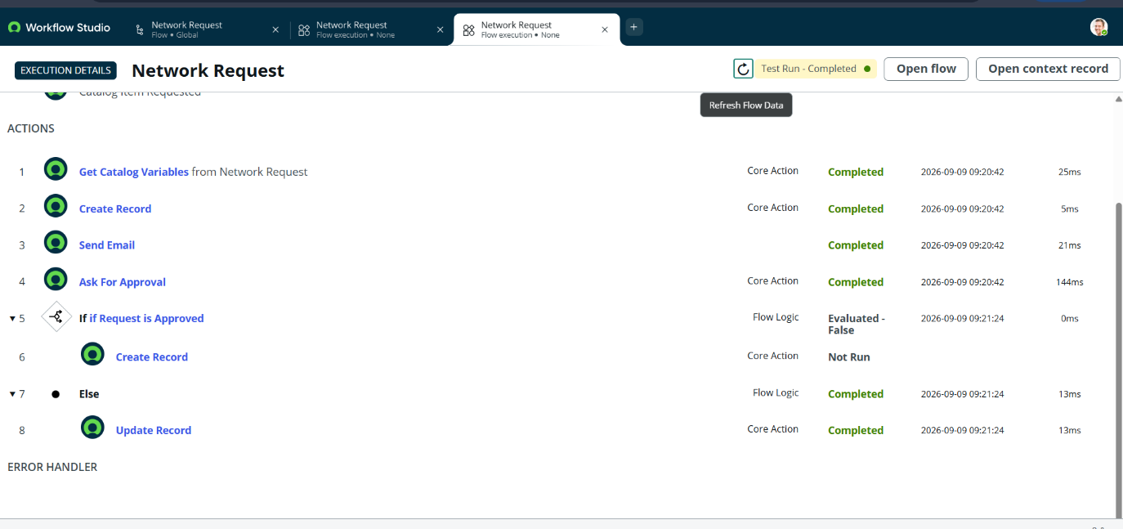
Fig.18 Retest after rejected
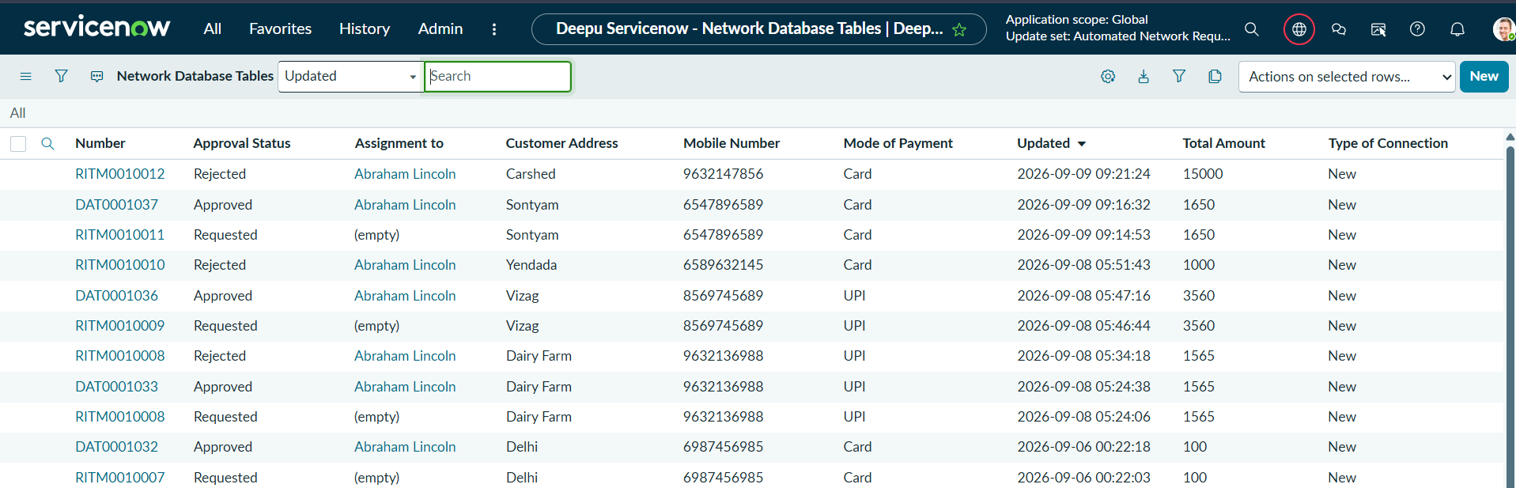
Fig.19 Updates a record that its rejected

8. ADVANTAGES & DISADVANTAGES

Advantages
- Reduces manual processing of network requests.
- Provides a centralized request management system.
- Simplifies network request submission.
- Provides structured and validated request information.
- Supports dynamic form behavior.
- Automates approval processing.
- Generates automated notifications.
- Provides request and approval status tracking.
- Improves visibility of the request lifecycle.
- Provides role- and ACL-based access control.
- Reduces repeated communication between users and administrators.
- Provides an organized and traceable workflow.

Disadvantages
- Requires a configured ServiceNow environment.
- Initial configuration and workflow development require ServiceNow knowledge.
- Changes to the request process may require administrator configuration.
- The system depends on the availability of the ServiceNow platform.
- Advanced customization may require additional scripting or platform configuration.
- Performance at very large scale would require separate load and scalability testing.

9. CONCLUSION
The Automated Network Request Management in ServiceNow project provides a centralized and automated approach for managing network-related service requests.
The system enables users to submit requests through the ServiceNow Service Portal using a structured Network Request Catalog Item. The configured form collects the required information and supports conditional field behavior.
Flow Designer automates the request processing, approval, notification, and status management activities. Network request information is maintained in a centralized Network Database, while ACL configurations help control access to records.
Functional testing confirmed that all defined test scenarios passed successfully. Overall, the project demonstrates how ServiceNow can be used to automate and manage a complete service request lifecycle efficiently.

10. FUTURE SCOPE
The system can be enhanced further with the following features:
- Integration with external network management systems.
- Automated assignment of requests to specific network teams.
- SLA configuration for monitoring request resolution time.
- Escalation notifications for delayed approvals or requests.
- Dashboard for administrators to monitor network requests.
- Reports based on request type, status, and processing time.
- Mobile access for request monitoring.
- Advanced analytics for identifying request trends.
- Integration with additional enterprise services.
- Automated request closure after successful fulfillment.
- Enhanced audit and monitoring capabilities.
- Self-service knowledge articles for common network issues.

11. APPENDIX

Source Code (if any)
The project is primarily developed and configured using the ServiceNow platform. The implementation consists mainly of ServiceNow configuration components such as:
- Service Catalog configuration.
- Catalog variables.
- Variable sets.
- ServiceNow tables.
- Flow Designer workflows.
- Approval configuration.
- Notification configuration.
- ACL/security configuration.
- ServiceNow scripting/configuration where required.
If any custom scripts were used during implementation, they can be included in this section.

Dataset Link
This project does not require a separate external dataset. Network request information is collected through the ServiceNow request form and maintained within the configured ServiceNow tables.
Dataset: Not Applicable / ServiceNow internal request data.

GitHub & Project Demo Link
GitHub Repository:
https://github.com/VijjapuMadhuri5/Automated-Network-Request-Management-in-ServiceNow
Project Demo:
https://drive.google.com/file/d/1pfB9gtfKB5DrPiPJamHhgulWbREvX4T0/view?usp=drive_link

